Ely Homework Grid
“Jurassic Planet” 🦖 – Autumn Term 1
Numeracy  Dinosaurs left big footprints behind! How big is your footprint? Draw around your foot on paper and ask a family member to draw around theirs. Measure each footprint using cubes, paper clips or a ruler. Complete the sentence; My footprint is _____ cm (clips / cubes) long.  _______'s footprint is _____ cm (clips / cubes) long.  My footprint is _____ cm (clips / cubes) longer/shorter than _______'s.  Imagine a T-Rex footprint was 100cm (clips / cubes) long. How many of your footprints would fit inside it?  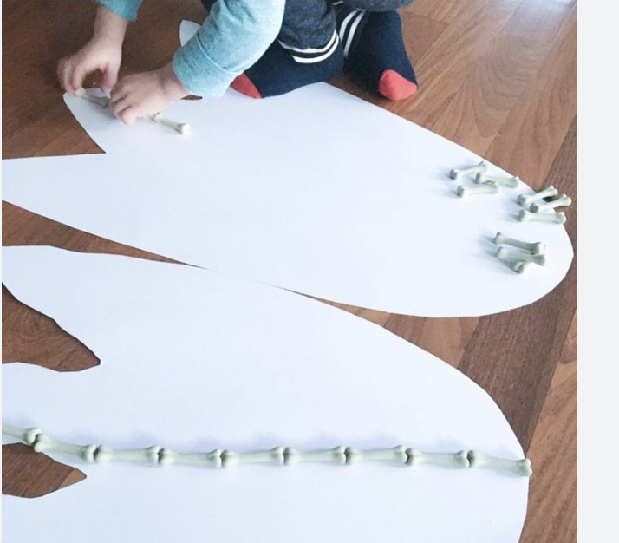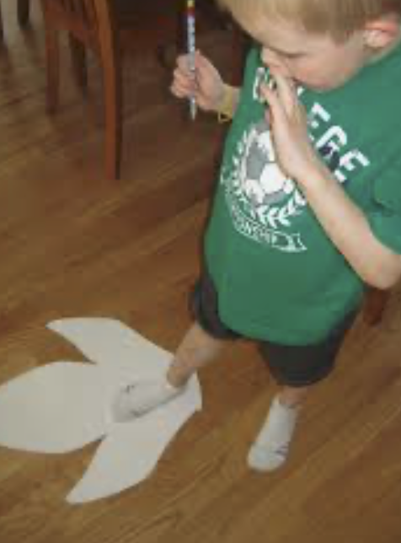 | STEM  Imagine that you are a dinosaur scientist! Choose a dinosaur and create a simple life cycle showing how it grew from a baby into an adult.  Draw or make a life cycle wheel with 4 stages:  - 🥚 Egg  - 🐣 Baby Dinosaur  - 🦖 Young Dinosaur  - 🦕 Adult Dinosaur  Bonus Challenge ⭐ Can you find out three interesting dinosaur facts! | PSE  Be a Helpful Herbivore - Many dinosaurs lived together and looked after their young. Your Mission; - Complete three acts of kindness during the week, e.g  - Help tidy up.  - Share a toy or game.  - Say something kind to a family member.  - Help set the table.  Draw a dinosaur egg each time you complete a kind act. When all your eggs have hatched, colour in a baby dinosaur! Reflection - Draw or write: "I felt happy when I helped ______ because ______."  ⭐ Challenge: Can you complete five acts of kindness?
Creative  Can you use recycled materials to create your own dinosaur?  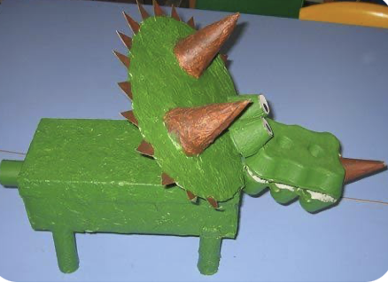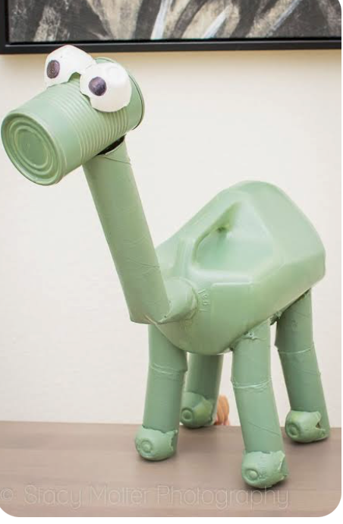 | Literacy  Linked to your STEM challenge Write one simple sentence about each stage. For example:  - "The dinosaur starts life inside an egg."  - "The baby dinosaur hatches out."  - "The young dinosaur grows bigger."  - "The adult dinosaur can lay eggs."  Extension; Write a short story about an adventure that your dinosaur goes on…. | PE – Dinosaur Movement Adventure! 🦖  Can you move like different dinosaurs?  Try;  T-Rex stomps – 20 steps  Pterodactyl wing flaps – 20 arm circles  Triceratops charges – run safely between two points 5 times  Stegosaurus stretches – hold 5 different stretches  Record Your Activity - Colour a dinosaur each time you complete the challenge. ⭐ Challenge: Create your own dinosaur movement and teach it to a family member.  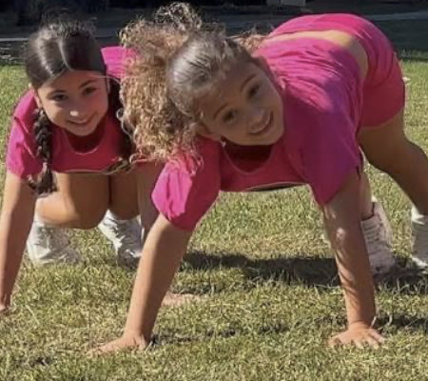
Extra challenges:
- RE- Our Christian value is ‘Thankfulness’ Think about how you could show thanks each day.
- ICT - Can you log into your own Hwb account independently? Practice at home and use your Google classroom to access weekly homework activities.

Don’t forget to read every night!

