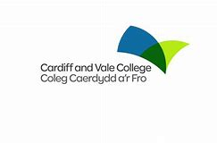 |  |  |  | Families Learning Together at Cardiff and Vale College

What is the Family Learning Project?
The Families Learning Together Project at CAVC aims to engage a large number of families and support parents with practical and fun ways of engaging with their children’s education. The team of qualified teachers deliver bespoke courses and workshops designed to take families on an exciting learning journey together. Courses are delivered in schools across Cardiff and the Vale and some have now been developed to include online. Courses are available at all key stages for families with children from nursery up to KS3.
Welsh medium and EAL courses are also available.

What are the benefits of Family Learning with CAVC?
In addition to providing parents with an understanding of how to support their children at all levels of progression there is an opportunity to gain a qualification. Also, as part of the course parents become college students and enjoy a visit to the college where they find out more about CAVC and further learning opportunities. Courses can be tailored to the needs of individual schools or groups and are all free.

How do the Family Learning Together courses work?
School based
Parent only session – During this session we work with the parents developing their educational skills and knowledge, identifying ways of supporting learning at home.
Joint session – The children join the parents for a practical, fun session of educational activities.

Online
Live sessions on Teams offering practical suggestions and guidance for parents to support their child’s learning. Sessions are recorded and can be accessed at their convenience and are supported with home activities.

Key facts
The success of the project continues to grow and 178 courses are planned for 2022 - 23 with an aim of reaching at least 1500 families

For further information please contact the Family Learning team
Families@cavc.ac.uk
Twitter CAVC_FLT
Watch this video to find out more

 |  | 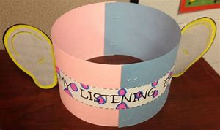
 |  | 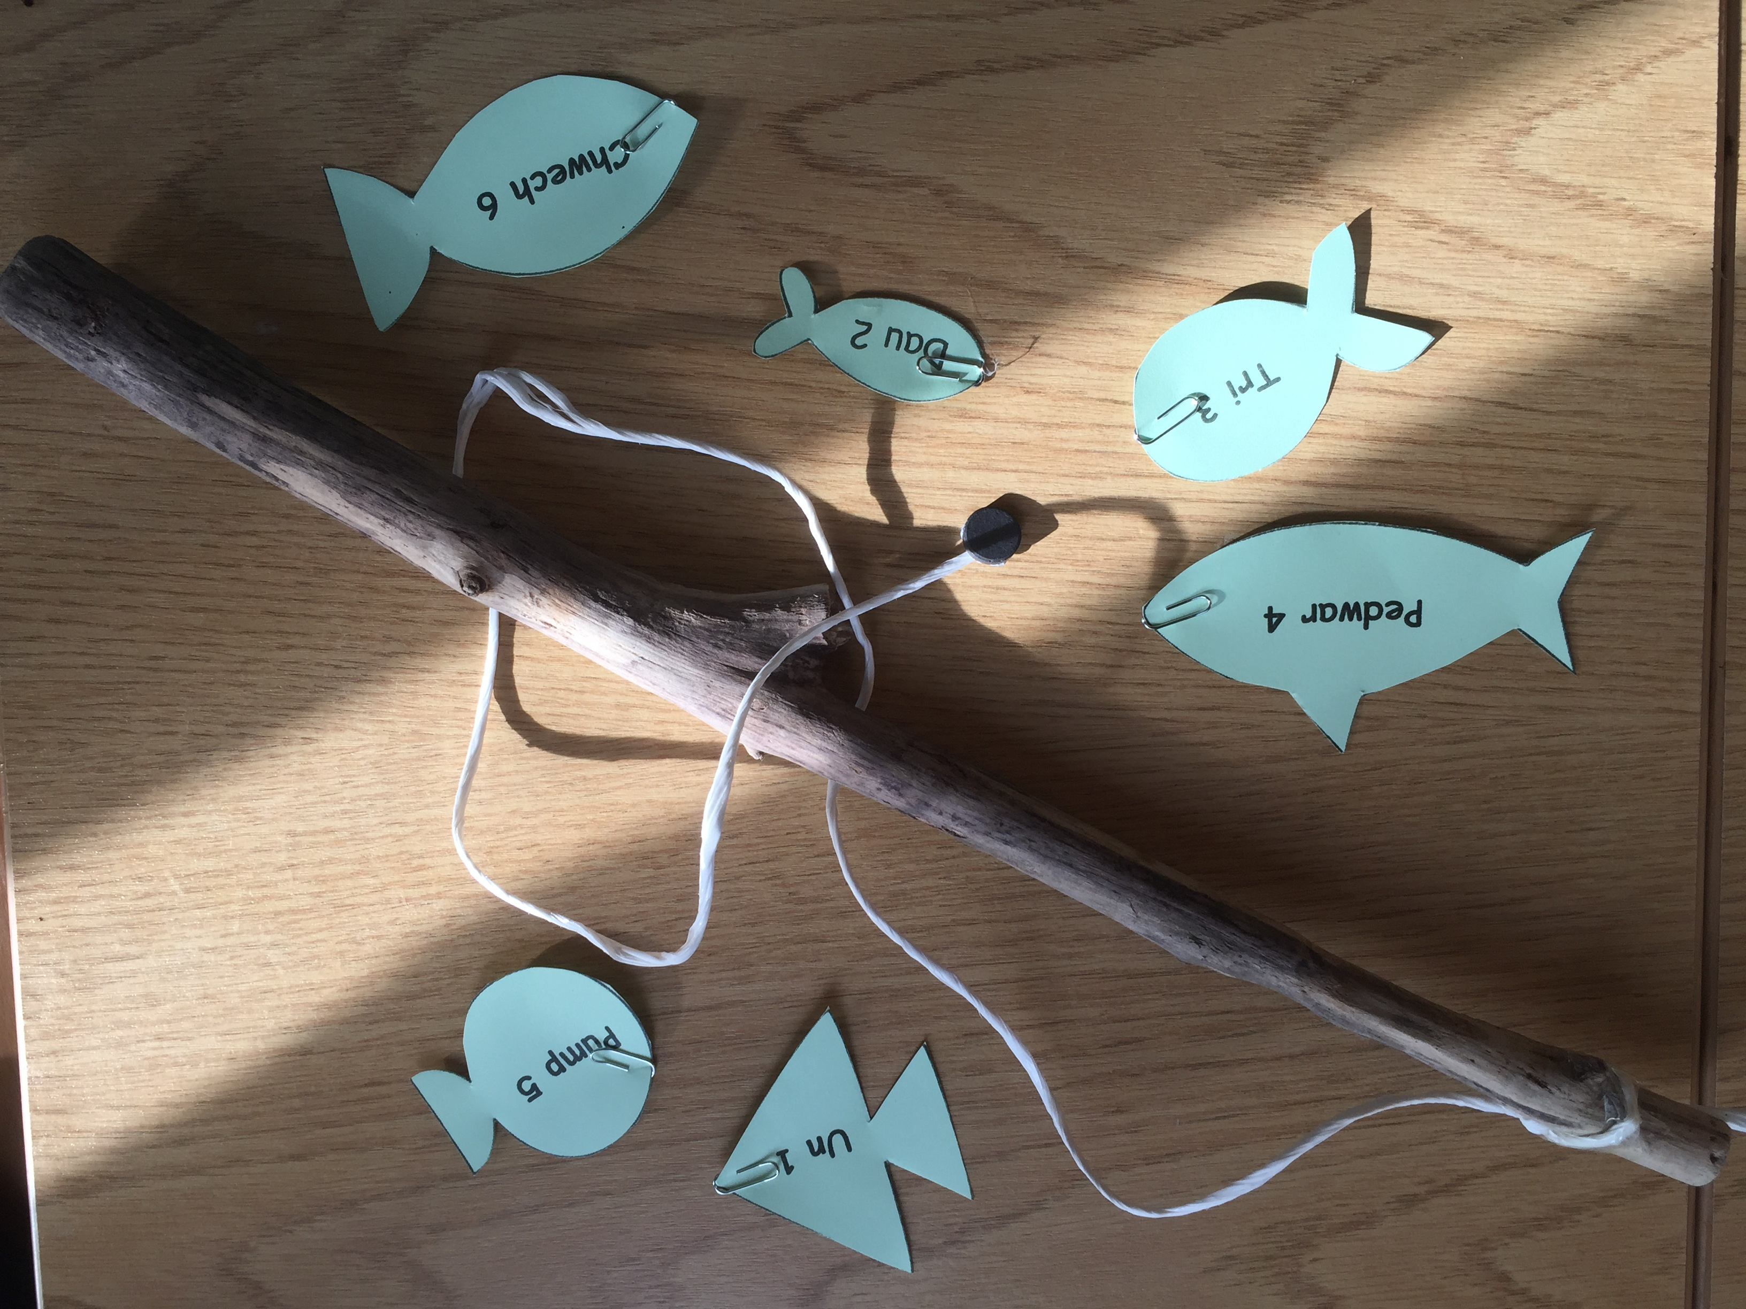
 |  | 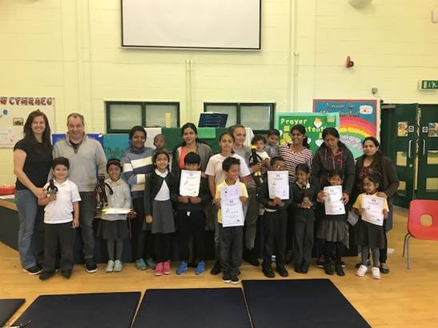
 | 

